The Producers of The Panama Deception & COVERUP: Behind the Iran Contra Affair
Present
SOLDIERS SPEAK OUT
Please join Academy Award Winning Director, Barbara Trent
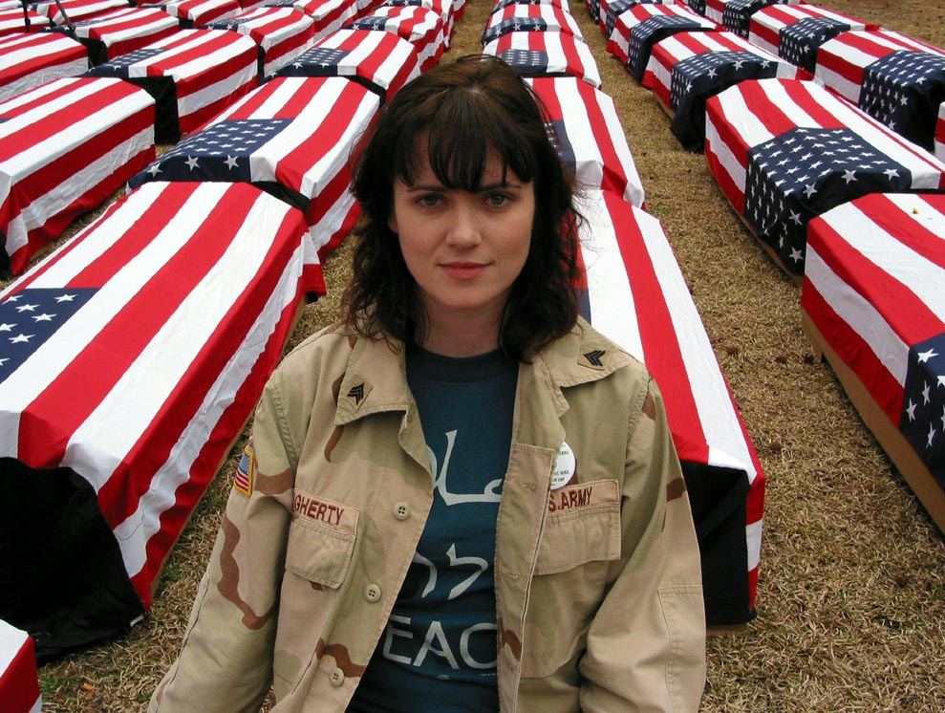
Kelly Dougherty, Iraq Veterans Against the War. Photo by Silke Mayer
for a Benefit Screening of the Empowerment Project’s newest Documentary.
Soldiers Speak Out is a powerful, first-hand testament to the reality of the military experience, told entirely in the words of American veterans who have been to war and are now opposing it.
Soldiers Speak Out sheds light on the growing and courageous anti-war and anti-occupation movement within the military and their families and serves as a counter-recruitment and organizing tool for activists, schools, and organizations. It provides a sober view of the war in Iraq and an important counterpoint to the "stay-the-course" rhetoric of the Bush administration.
Also: In celebration of the re-release of her Oscar-winning film, The Panama Deception
Special feature Panama to Iraq: The Trajectory of U.S. Militarism, (8 min.) will be screened.
Featuring former Panamanian Diplomat Humberto Brown, Phyllis Bennis (Institute for Policy Studies, and author of Challenging Empire), Greg Grandin (Professor of History at NYU) and former CIA analyst David MacMichael discussing the eerie parallels between the two invasions.
Wednesday, April 2nd
6:30pm wine & cheese reception
7:00pm Benefit Presentation & Q&A Session
The Roxy Theater
718 S. Higgins Ave., Missoula MT 59803
$10 Donation suggested ($5 living lightly)
Sponsored by Jeannette Rankin Peace Center, University of Montana
Students for Peace and Justice and Empowerment Project

RSVP: Jeannette Rankin Peace Center (406) 543-3955, peace@jrpc.org
For more information about Empowerment Project: www.empowermentproject.org

